This tool development exercise will assess your ability to create and modify Python and Bash scripts to automate common cybersecurity tasks. You will demonstrate your skills in using scripting fundamentals, such as conditional statements, loops, and user input handling.

To receive full credit, ensure your scripts are properly cited at the top and commented throughout. Include screenshots of your script outputs where requested in the lab instructions.

**Submission Requirements:**

* Submit the following through Brightspace:
  + Week 3 - Tool Development 3 (**this document**) with all required screenshots.
    - Plus the link to your GitHub repository where your Python & Bash script files were pushed to a Week 3 directory in your main ISS 212 repository.
    - Scripts must be uploaded to BrightSpace if you are having issues with GitHub.

**Scenario 1 Network Traffic Analysis Python Script Output Screenshot**

**Scenario 1 – Network Traffic Analysis Python Script Output**

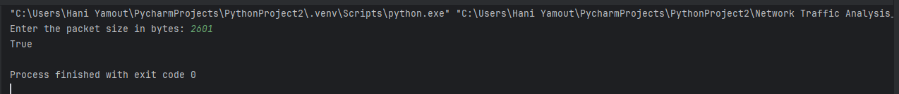

**Scenario 2 Protocol Love Python Script Output 1, 2, 3 Screenshots**

**Scenario 2.1 – Protocol Love Python Script Output**

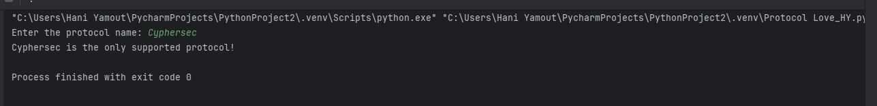

**Scenario 2.2 – Protocol Love Python Script Output**

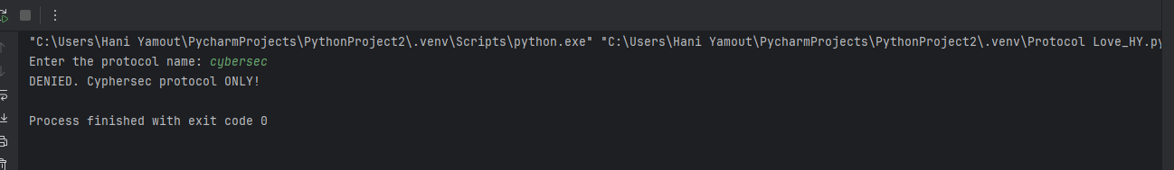

**Scenario 2.3 – Protocol Love Python Script Output**

**Scenario 3 Data Security Tax Calculation Python Script Output Screenshot**

**Scenario 3 Data Security Tax Calculation Python Script Output**



**Scenario 4 Patch Cycle Python Script Output 1, 2, 3 Screenshots**

**Scenario 4.1 Patch Cycle Python Script Output**



**Scenario 4.2 Patch Cycle Python Script Output**



**Scenario 4.3 Patch Cycle Python Script Output**

**Bash Script Block 1-4 Screenshots**

**Bash Script Block 1**

**Bash Script Block 2**

**Bash Script Block 3**

**Bash Script Block 4**

**Bash Execution Screenshot**

**  
GitHub Repository Link: https://github.com/hyamout/ISS212-Yamout**